Home Learning: Class 4: Week Commencing 18th May

Please email completed work, pictures, photos or other examples of Home Learning to:
Class4@witheridge.devon.sch.uk
Should you have any questions, or need any further support, please don’t hesitate to ask!
You can also find an explanation of this week’s tasks on this video:
https://youtu.be/gUvDqRdsvY4

Thanks.

Mrs Nott

English:
Task | √
- Find the ‘Mo Farah’ document on the Home Learning resources. Read all about this Olympic champion. Then find the ‘Olympic Champion Fact File’ document. Use all of the information you have found about Mo Farah to complete the fact file sheet. Don’t worry if you can’t print this off – you can record the same information in your book, and choose how you present it.
You may also want to watch this short video about Mo Farah:
https://youtu.be/ymIRjFzqIsU
- Visit https://www.bbc.co.uk/bitesize/articles/z6g98xs for an interactive lesson revising the use of relative clauses. You can complete the activities online. There is also a ‘Relative Clauses’ activity sheet on the Home Learning area. Don’t worry if you can’t print this, you can simply write out the sentences with the correct endings in your book. I’ve also included the answers, and a parent guide to terminology to help you with this activity.
- Find the ‘ough Error Correction’ document in the Home Learning area. In the first version, there are spelling mistakes in the story. Can you spot them all and write the correctly spelt version of those words in your book? I’ve also included the story with all the ‘ough’ words corrected so you can check how you got on.
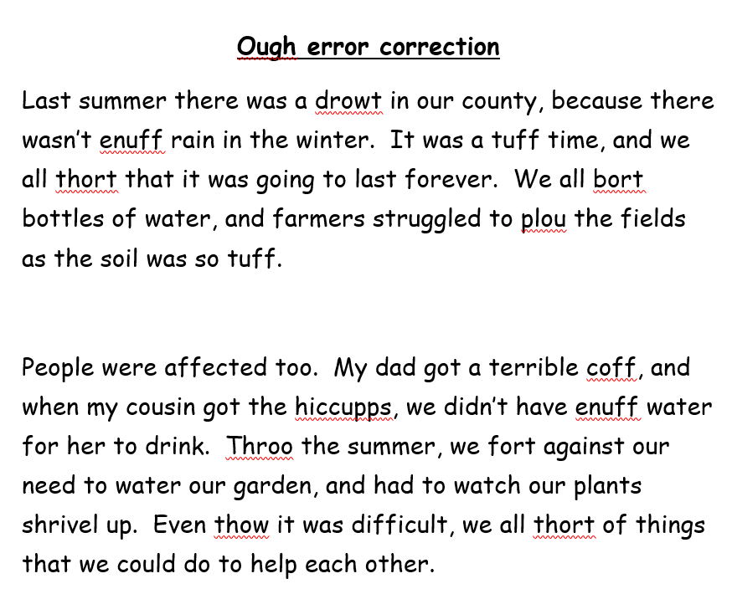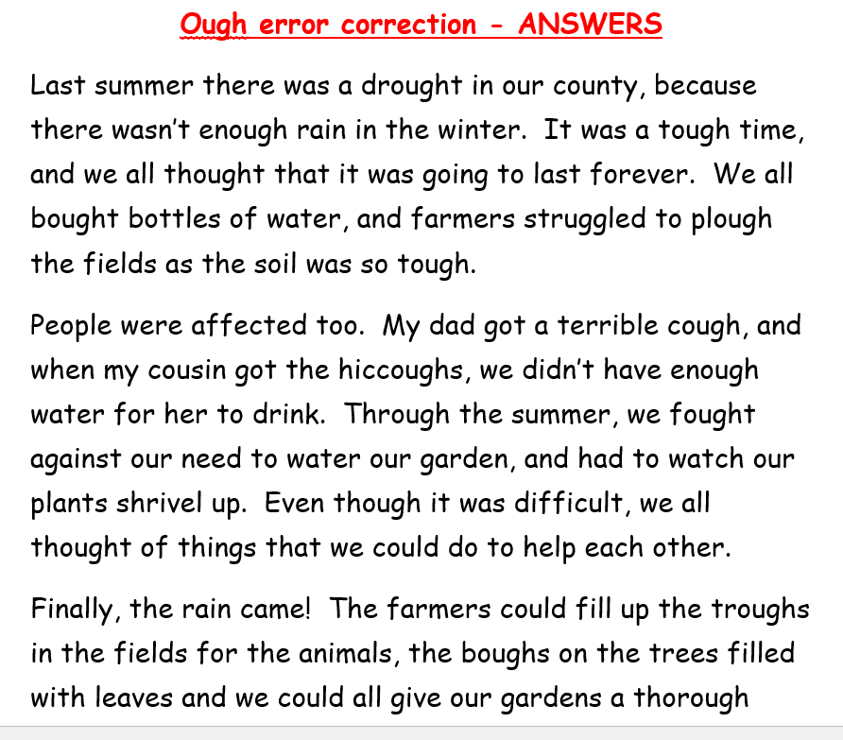
- Find the ‘Mo Farah’ document on the Home Learning area. Read the information and answer the questions in your book.
I have also included the answers here so you can check how you’ve got on. Remember, it will help your learning best if you have a go by yourself first, then check to see if you are correct!
- Read your book every day! Don’t forget, there are over 40,000 books to choose from on Epic!

Maths:
Task | √
- Watch the video lesson, ‘Calculate with Decimals’ by following this link:
- https://youtu.be/ImhwkrvcLxA
Complete the chunks in your book.

- Visit https://www.thenational.academy/year-6/maths/decimal-equivalents-of-fractions-year-6-wk2-2
This will take you to an online lesson from the Oak National Academy about Decimal Equivalents of Fractions. There is a quiz, a video, and an online activity to complete.

- Find the ‘Fraction and Decimal Equivalents’ document on the Home Learning area. Complete the activities in your book. I have also included the answers so you can check how you got on. Remember, it helps your learning best if you have a go by yourself first, then use the answers to check your work afterwards!
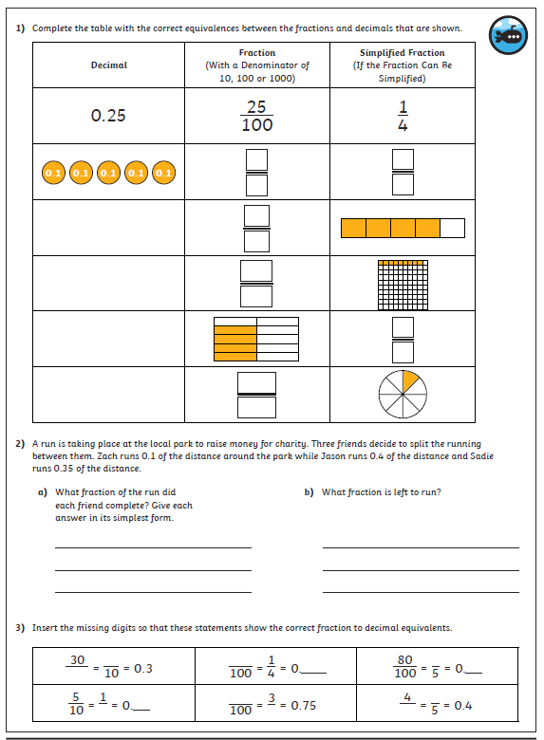

- Log on to Mathletics and complete the assigned activities. These will be new each week, and related to the other home learning tasks set in maths.
- Practise TT Rockstars

Science:
Task | √
Visit https://www.thenational.academy/year-6/foundation/which-organisms-lived-during-each-era-of-time-year-6-wk4-3
This will take you to the Oak National Academy, Year 6, Science, Lesson 4.
Here you will learn more about extinction and geological eras. There’s a quiz, a video and some short activities to complete.

Computing:
Task | √
Log on to https://www.khanacademy.org/computing/computer-programming
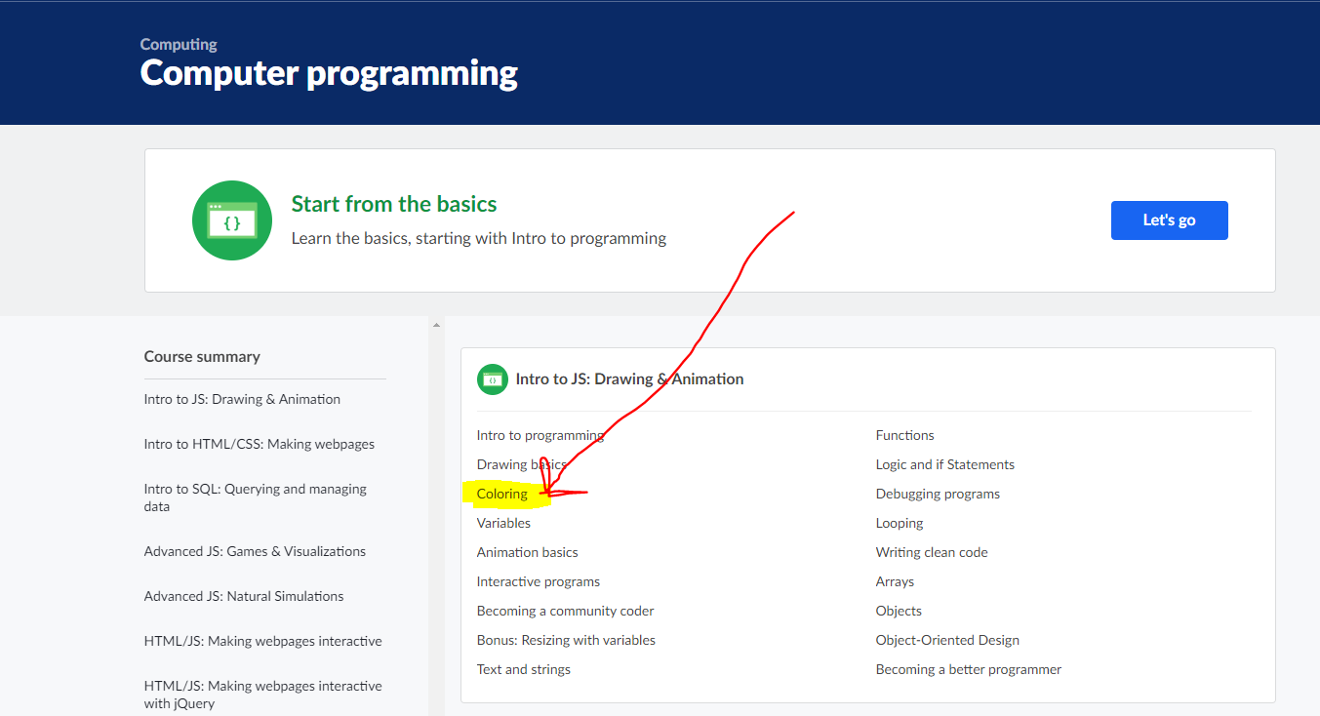
Click on the ‘coloring’ link to take you to an online lesson on using code to create colour in your drawings. There are videos and online challenges to complete.

Topic:
Task | √
Find the ‘Olympic Symbols’ presentation on the Home Learning area. Use this information to find out about some of the Olympic symbols, and what each symbol represents.

Use your own researching skills to find out more about the symbols used at the Olympic Games. Choose how you would like to present your learning.

You could:
- Make a poster
- Draw a picture of some of the symbols used at the Olympics
- Design a new Olympic symbol or motto and explain what it represents
- Make a PowerPoint presentation
- Write a quiz about Olympic symbols

Email me your completed work at class4@witheridge.devon.sch.uk
I look forward to seeing what interesting facts you find!

