Chunk 1
b) Here is a shaded square on For each of these points, put a tick to
x and y axes. show if it is inside or outside the square.
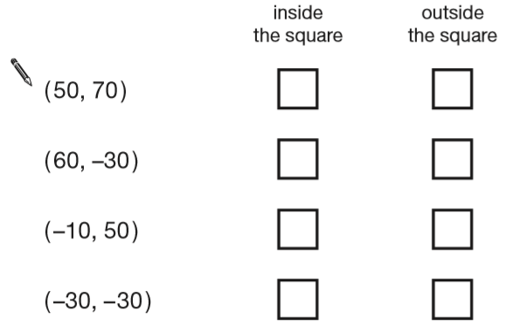
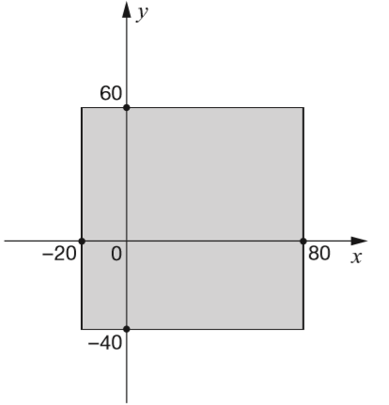
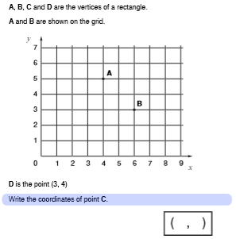
Chunk 2
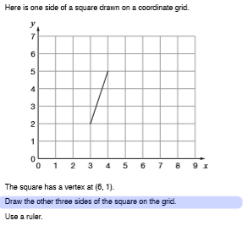

Chunk 3
a) This diagram shows 2 identical b) Here is a symmetrical pentagon.
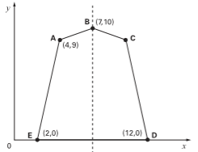
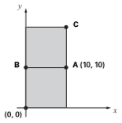
squares.

What are the co-ordinates of:
B = ( ___ , ___ ) What are the co-ordinates of C?
C = ( ___ , ___ )
C = ( ___ , ___ )

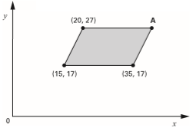
c) Here is a parallelogram.

What are the co-ordinates of point A?

A = ( ___ , ___ )

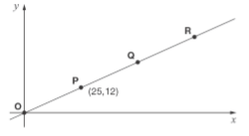
d) Here is a line on a
co-ordinate axis.

Points O, P, Q and R are equally spaced.
The co-ordinates of P are (25,12).

What are the
co-ordinates of R?
R = ( ___ , ___ )

