Pre-school and Reception Home Learning
WC 12.10.20

Activity 1: Harvest
Draw a picture of your favourite fruit and vegetables – if you have these at home you could look carefully at them before you begin. You could cut your items in half so that you can have a really good look. Talk to your grown up about what you notice and try to use the right colours to draw or colour your fruit/vegetable.
Activity 2: Role Play
Make your own farm shop and role play being the shop keeper and the customer. It would be great to sort your produce into fruit or vegetables. You will need some paper and pencils to make a shopping list and some receipts and some coins. You could extend your play to some pretend cooking.
Activity 3: Autumn Crafts
Use plasticise, modelling clay or make some play doh and create some conker crafts – if you have any. Alternatively, you could make a hedgehog and find some sticks to use for his spikes.
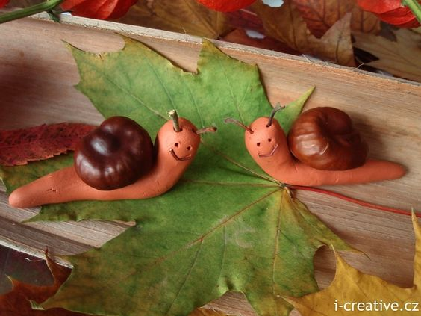
Reception Maths
This week at school, we will be making vegetable soup and apples crumble – you could make these or some other dishes at home with the ingredients you have available. Try to include some measuring using scales and measuring jugs if you can and count carefully as you follow your recipe.
This week we will also be watching the following episodes of Numberblocks. Please try to watch these and complete the activities below:
https://www.bbc.co.uk/iplayer/episode/b08dnngm/numberblocks-series-1-stampolines
- Play some games with a dice and play some dominoes – you could make your own dominoes or if you don’t have any.
https://www.bbc.co.uk/iplayer/episode/b08dr1l3/numberblocks-series-1-the-whole-of-me
- Watch this episode a few times and try to join in with the singing.
Reception Literacy
Last week we learnt the sounds: c, k, u, b, f
Can you play eye spy using these sounds and items from around your house?
Can you practice writing these sounds being careful to form the letters as well as you can by starting and finishing in the correct place.
If you have any of these letters in your name, then practice these ones extra hard so that you can get even better at writing your name.
Last week, we learnt about the words: ingredients and equipment. Can you tell or talk to a grown up about what these words mean?

